KM Tactical Dealer Application 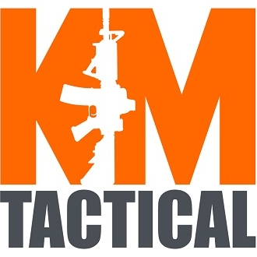
Legal Name:_________________________ Trade Name: _______________________________
State of Incorporation: ________________ Federal Employer I.D. #______________________
Address:_____________________________ Phone Number:_____________________________
Email Address:_______________________ Website:___________________________________
Contact Name and Phone Number:______________________________________________________
Type of Business:
- Brick & Mortar
- Online
- Ebay/Amazon
- Trade Shows
Paperwork Needed for Tax-Exempt Sales (Dealer Sales)
To become a tax-exempt Dealer or Distributor for KM Tactical, the following information or paperwork is needed to create a reseller account:
- FFL or State Business License
- Federal Employer I.D. #
- Local/State Resellers or Tax-Exempt paperwork from state of physical location
- MO-149 Tax Exempt Form
- Completed Dealer Application

